GUI PROGRAM

Part 1: Basics

Part 2: Isotherms

Part 3: Fluorescence

Part 4: Reflectivity

**Part 1: Basics**

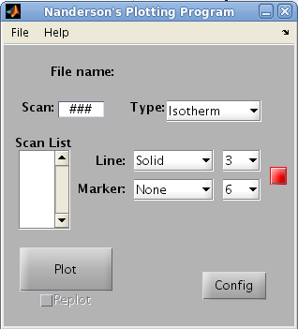

Set the Matlab current folder to the folder of the program named **LiquidGUI**. With Matlab in the above directory, the software can be started by using the command **LiquidGUI**. The GUI main window should appear and look like the figure on the right:

The first important step when starting the plotting program is to find the desired dat file and load it into the program. At the top left corner, select **File -> Open dat...** (or Control + O). This will cause a file search box to open and allow you to easily find the **.dat** file from your experiment.

The next step is to select the type of scan to be plotted. This can be done by selecting the **Type** pop-up box and picking between Isotherm, Fluorescence, and Reflectivity. An appropriate scan must then be entered into the **Scan** box that corresponds to the currently selected scan type. If an incorrect scan is given, there is a good chance that the program will either give an error message or the plot will just look bad.

Once the **.dat file**, s**can box, and type box** have been selected, the only thing left to do is to hit the plot button. Assuming that the scans were correct, the graph will pop-up. After it is plotted, the scan number will appear in the **Scan List box**. Another scan can be plotted on top of the previous scan by checking the **Replot** box. Plotting without this box checked will cause all previous scans to be deleted and only the most recent to appear.

As a scan is plotted, it will use the properties currently defined by the **Line,** **Marker** and **Color** boxes. Any of these properties can be changed to their desired value before plotting, or alternatively, once a scan has been plotted it is select-able in the **Scan List** box and then have its properties modified.

Closing the **graph figure** of any scan type will automatically delete any plotted scans from the scan list box to allow for a fresh start. Also, selecting a scan in the scan list box and deleting it will cause it to be deleted from the **graph figure.**

**Part 2: Isotherm**

After following through the basics with a scan type of Isotherm, it should look like the following:

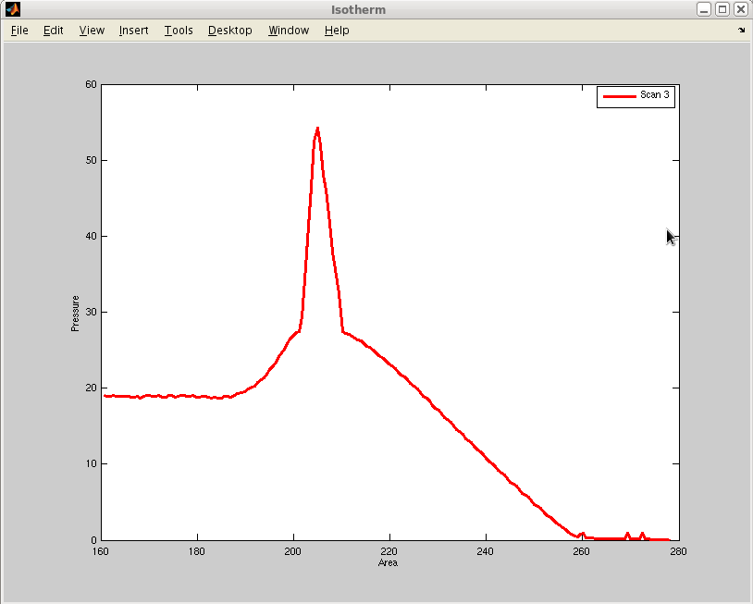

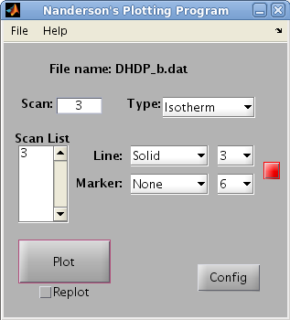

Notice how the **dat file** is listed and the scan appears in the **Scan List box**. Unlike Fluorescence and Reflectivity, the Isotherm tab is completely automatic and has very little available for change other than the **Line, Marker, and Color** styles.

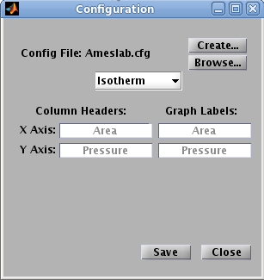However, despite the term Isotherm referring to a Pressure vs Area plot, it is possible to plot any two columns of data from a scan in the **dat file** by specifying the column names. Select the **Config** box in the bottom right corner of the Main Window to get the Config options which should look like the following:

By changing the names in the **Column Headers** for both X Axis and Y Axis, you can change the column selected by program while fitting. The names are case insensitive, but incorrect spelling will cause the program to be unable to find the correct column. The Axis labels on the graph are also changeable with inputting new names into the **Graph Labels** boxes.

For example, if you were wanting to plot the scans from a line up, you would use the name **DetHgt** for the X Axis Column Header and **Detector** for the Y Axis Column Header. You could then have the X Axis and Y Axis Graph Labels as  **Detector Height** and **Detector**, respectively.

After changing any values, the text in the box will be **black**. This indicates that it has not been saved. By hitting the **Save Button** the names will be saved into the **CFG** file listed above (the default is Ameslab.cfg). If the values are not saved, they will revert back to the previous values upon closing the **Configuration** window.

**Part 3: Fluorescence**

The first thing that is noticeable when changing from **Isotherm** to **Fluorescence** is that the size of the main window changes and new options appear for modifying the graphs.

When a Fluorescence graph is plotted, it creates a single figure with 4 subplots. The first plot, in the upper left corner, is the color map of the **Energy vs Qz matrix**. The second plot, in the upper right corner, is an integration over the energy range to give **Intensity vs Qz (Energy Slice)**. The third plot, in the lower right, is an integration from the **minimum Qz to the Critical Angle (Surface Slice)** to give Intensity vs Energy. The last plot, in the bottom left, is integration from the **Critical Angle to the maximum Qz (Bulk Slice)** to give Intensity vs Energy.

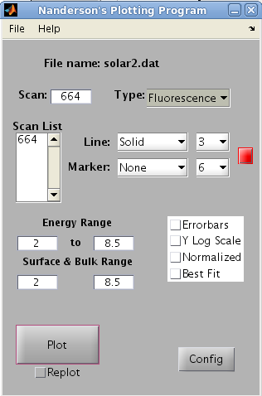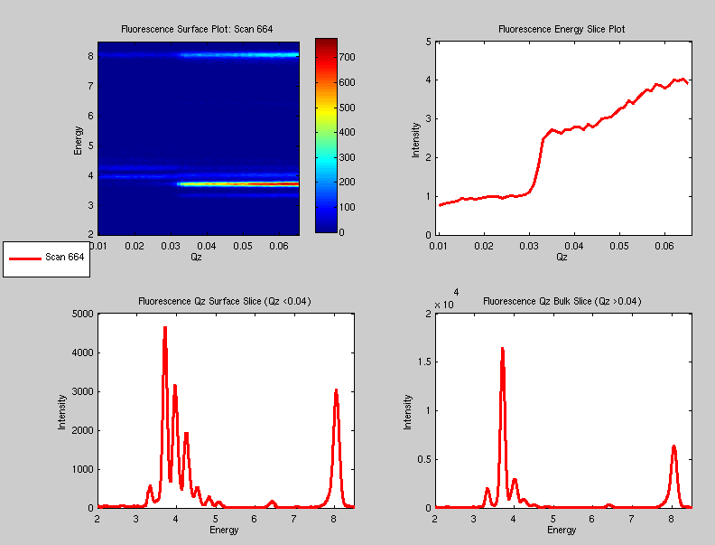

In the Main Window with Fluorescence, the most important boxes are those for **Energy Range** and **Surface & Bulk Range**. By changing the **Energy Range** boxes, you simultaneously change the **energy limits** (y-axis) of the color map and the **integration range of the Energy Slice Plot** (upper right). On the other hand, changing the **Surface & Bulk Range** lets you set the limits for the energy (x-axis) in **both of the bottom plots**. There is also currently an option to turn on **errorbars for the Energy Slice**, however, log-scale, normalization, and best fit are not currently implemented. Just as with the Isotherm, specific scans can be selected and their line, marker, and color properties modified.

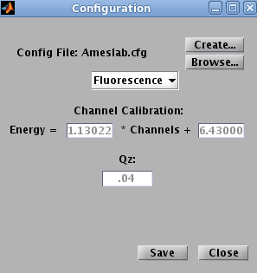As with the Isotherm, there is a **Fluorescence Configuration Page** accessible by hitting the Config button. Inital values are loaded in from the **Config file** (in this case Ameslab.cfg). These page allows you to give the conversion values to **convert channels from the detector into energy**. The Qc value is for your Critical Angle and is used for integration with the Surface Slice and Bulk Slice.

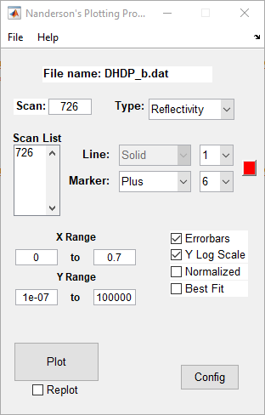**Part 4: Reflectivity**

Just as when changing from **Isotherm** to **Fluorescence**, changing to **Reflectivity** will resize the main window and change various options to those used for plotting reflectivity. Similar with **Fluorescence**, the **X and Y ranges** can be changed to rescale the axis for various data sets. Upon initially plotting a reflectivity scan, the data doesn’t appear very interesting, however, checking the **Y Log Scale** allows for viewing of the surface features. The example below uses the **Y Log Scale** as well as **Errorbars** which are automatically calculated from the data. The data can also be normalized with respect to water by checking the **Normalized** box.

Currently, the **Best Fit** option has not been implemented and the **Config** window is empty as there are currently no reflectivity options that differ across the various instruments.

